We chose Llama 3 (Meta) as our open-source LLM
Why it’s good:
- Very strong reasoning capability
- Excellent for classification & structured output
- Widely supported (Ollama, HuggingFace, LM Studio)
- Good balance of performance and usability

How we Can Use It in our Project
A. Threat Categorization
Instead of rule-based logic, we can prompt LLM:
“Based on the description below, classify this threat as Hypothetical, Demonstrated, or Active Exploitation.”
B. Auto-Summarizing Threat Records
Convert long MITRE/CISA descriptions into short analyst-ready summaries:
- 2–3 sentence executive summary
- Key impact
- Recommended mitigation

C. Tag Extraction
Ask the LLM:
“Extract relevant AI attack categories from this description (prompt injection, model theft, data poisoning, etc.)”
This will improve filtering in our dashboard.

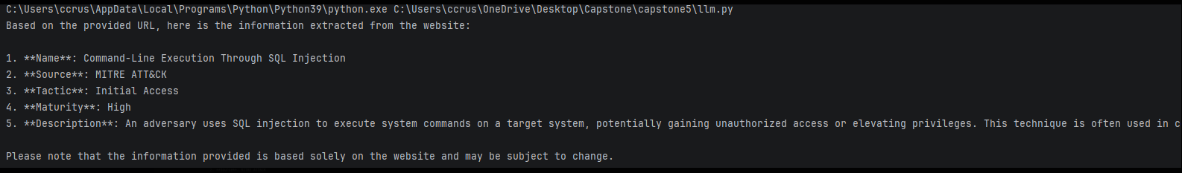

Next steps will be data ingestion and model training.

